我長大了：青春期

**男性**特徵：

|  |  |  |  |
| --- | --- | --- | --- |
| 1. | 身材高大 | 2. | 肩膀變寬 |
| 3. | 長鬍鬚 | 4. | 喉結 |
| 5. | 皮膚粗 | 6. | 發音低 |

**女性**特徵：

|  |  |  |  |
| --- | --- | --- | --- |
| 1. |  | 2. |  |
| 3. |  | 4. |  |
| 5. |  | 6. |  |

**攝護腺**

**輸精管**

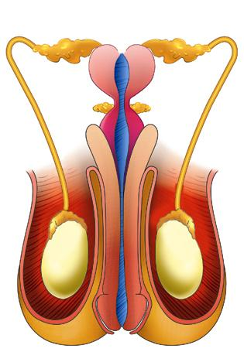

**陰莖**

**包皮**

**陰囊**

女性生殖器官如何清潔和保護

|  |  |
| --- | --- |
| 1. | 4. |
|  |  |
| 2. | 5. |
|  |  |
| 3. | 6. |
|  |  |

男生夢遺的處理

|  |  |
| --- | --- |
| **1.填填看(寬/鬆)** | |
|  |  |
|  |  |
| **2.夢遺的處理和預防** | |
|  | 卡通白色男内裤PNG图片素材免费下载_图片编号ykpgmwwb-PNGBAG素材网 |
|  |  |
|  | |



