我長大了：青春期

**男性**特徵：

|  |  |  |  |
| --- | --- | --- | --- |
| 1. | 身材高大 | 2. | 肩膀變寬 |
| 3. | 長鬍鬚 | 4. | 喉結 |
| 5. | 皮膚粗 | 6. | 發音低 |

**女性**特徵：

|  |  |  |  |
| --- | --- | --- | --- |
| 1. |  | 2. |  |
| 3. |  | 4. |  |
| 5. |  | 6. |  |

**攝護腺**

**輸精管**

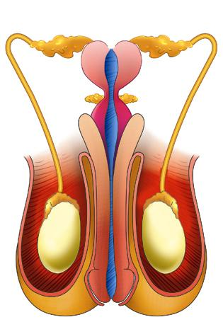

**陰莖**

**包皮**

**陰囊**



