國立花蓮特殊教育學校109-2 彩虹班作業單

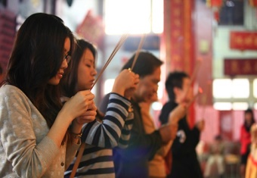日期： 姓名：

|  |  |
| --- | --- |
| 拜 | 拜 |
|  |  |
|  |  |
|  |  |
|  |  |
|  |  |
|  |  |

|  |  |
| --- | --- |
| 拜 | 年 |
|  |  |
|  |  |
|  |  |
|  |  |
|  |  |
|  |  |

|  |  |
| --- | --- |
| 拜 | 託 |
|  |  |
|  |  |
|  |  |
|  |  |
|  |  |
|  |  |