國立花蓮特殊教育學校109-2 彩虹班作業單

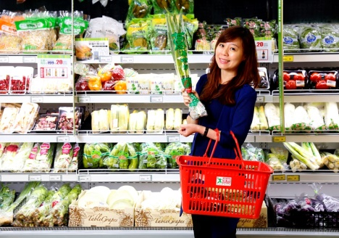日期： 姓名：

|  |  |
| --- | --- |
| 白 | 髮 |
| 白 | 髮 |
| 白 | 髮 |
|  |  |
|  |  |
|  |  |
|  |  |

|  |  |
| --- | --- |
| 奶 | 奶 |
| 奶 | 奶 |
| 奶 | 奶 |
|  |  |
|  |  |
|  |  |
|  |  |

|  |  |
| --- | --- |
| 買 | 菜 |
| 買 | 菜 |
| 買 | 菜 |
|  |  |
|  |  |
|  |  |
|  |  |