國立花蓮特殊教育學校109-2 彩虹班作業單

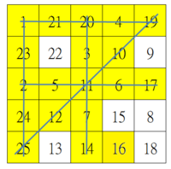日期： 姓名：

|  |  |
| --- | --- |
| 剛 | 果 |
| 剛 | 果 |
| 剛 | 果 |
|  |  |
|  |  |
|  |  |
|  |  |

|  |  |
| --- | --- |
| 賓 | 果 |
| 賓 | 果 |
| 賓 | 果 |
|  |  |
|  |  |
|  |  |
|  |  |

|  |  |
| --- | --- |
| 糖 | 果 |
| 糖 | 果 |
| 糖 | 果 |
|  |  |
|  |  |
|  |  |
|  |  |