國立花蓮特殊教育學校109-2 彩虹班作業單

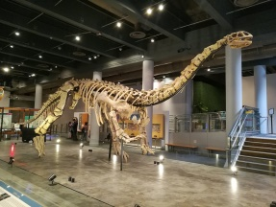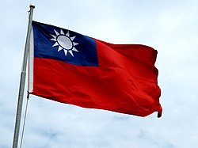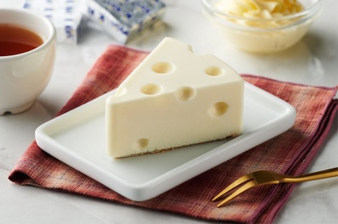日期： 姓名：

|  |  |
| --- | --- |
| 乳 | 酪 |
|  |  |
|  |  |
|  |  |
|  |  |
|  |  |
|  |  |

|  |  |
| --- | --- |
| 國 | 旗 |
|  |  |
|  |  |
|  |  |
|  |  |
|  |  |
|  |  |

|  |  |  |
| --- | --- | --- |
| 博 | 物 | 館 |
|  |  |  |
|  |  |  |
|  |  |  |
|  |  |  |
|  |  |  |
|  |  |  |